GONGATI NANDI VARDHAN

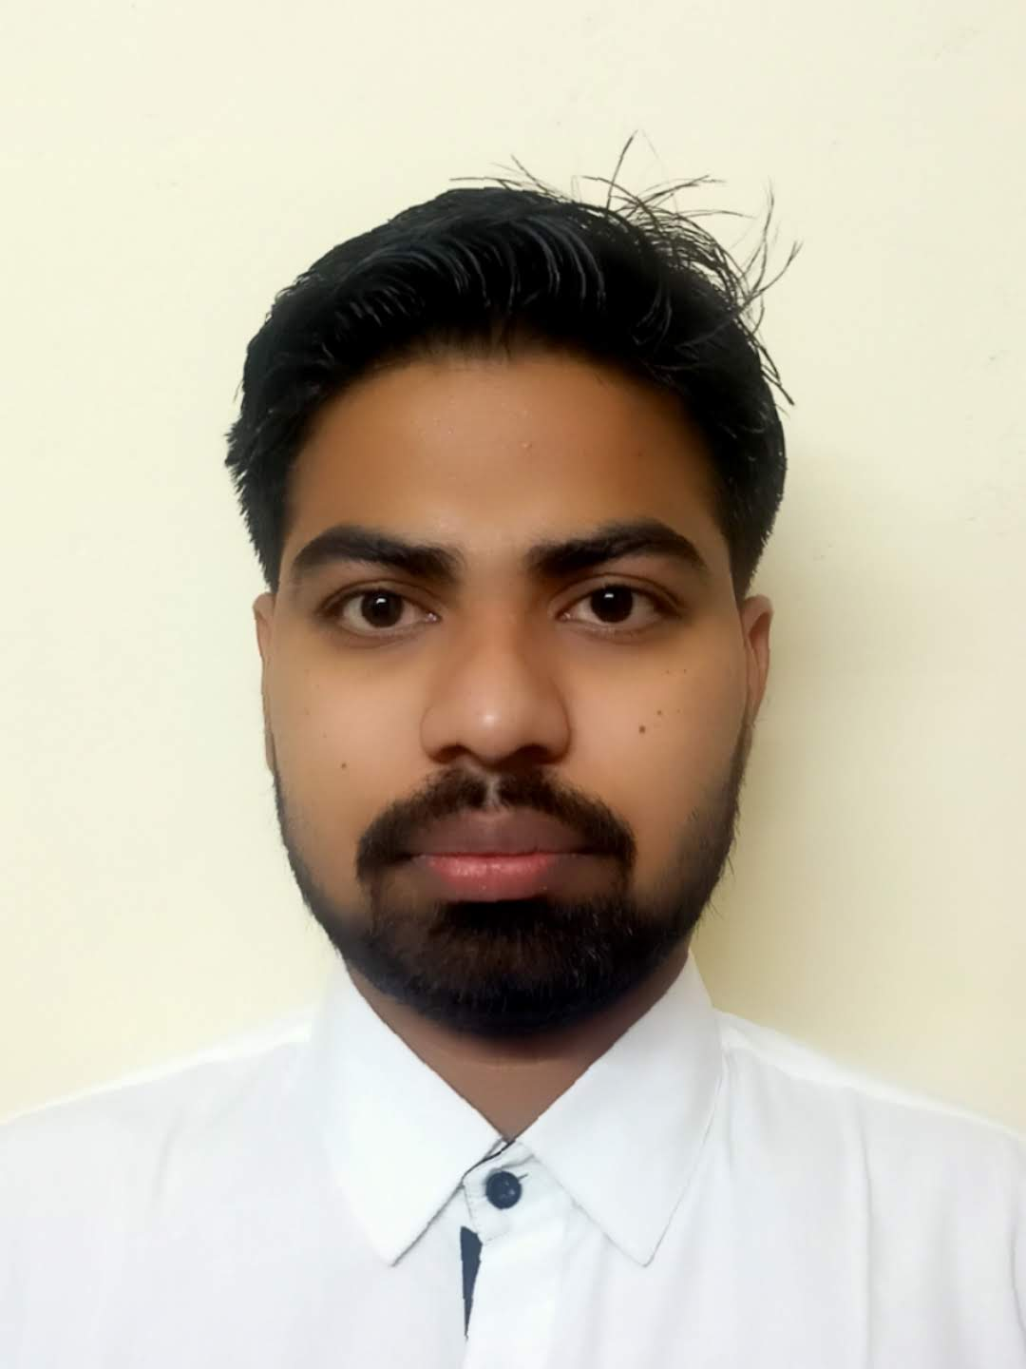

REDDY

Contact:8297390076

Mail id : nandireddy13@gmail.com

# PROFESSIONAL PROFILE:

A Proficient Quality Assurance Engineer Specialized in Selenium and Core java adept at crafting robust and scalable automation frameworks to expedite software processes.. I am Proficient in utilizing other testing frameworks and tools, such as TestNG,Maven, Cucumber to Streamline test execution and reporting processes. I leverage my knowledge of Xpath and CSS selectors to efficiently locate and interact with web elements, ensuring reliable test automation across web application. I have 1year 8months in a Mobile Testing and java with selenium. Seeking a challenging and satisfying career as a dedicated professional to enrich my personal skills in conjunction with the organization’s goal and objective.

# EXPERINECE:

## Cognizant – Sch H-2.8.1 Tax Services ITO | From March 2023 To June 2024

 Proficient in automating mobile tests using Selenium and Java, with hands-on experience in Crafting and Managing test scripts to handle various testcases efficiently.

 Utilized Selenium Web drivers alongside java programming to automate mobile testing scenario’s, ensuring through validation of application functionalities across different devices and platforms.

 I have worked Robust automation framework, enhancing testing efficiency and accuracy throughout software development lifecycle.

**SKILLS:**

* Core Java
* Selenium
* PostgreSQL
* Python
* C programming
* C++
* Html
* CSS

# EDUCATION:

## B.Tech - GITAM University [2018 - 2022]

 Course :Computer Science and Engineering  CGPA: 7.74/10

## Intermediate - Narayana Junior College [2016 - 2018 ]

 Course: MPC

 Percentage: 94.4

## Board of Secondary Education - Kakatiya high school [2015-2016]

 GPA:85.5/10

# PROJECTS:

**Human Activity Detection [Feb 2022]**

 Human Activity detection project using machine learning which is used to detect the activities of a person and it is used in hospitals and also in public places.

## Online Examination System | From July 2022

 Online Examinations System is a web application where the students can write the exams online.

# PERSONAL DETAILS:

Father's Name : V Ramana  DOB : 29-10-2000



 Marital Status : Single  Gender : Male

 Nationality : Indian

 Languages Known : English, Telugu, Hindi

 Personal Interests : Cricket, Reading ,Travelling, Photography, Video editing.

# Declaration

I hereby declare that the above-mentioned particulars are true to the best of my knowledge and belief.

**Regards, (Yaswanth V)**